/******************************************************************************
***
* DPS912-Lab4
* I declare that this lab is my own work in accordance with Seneca Academic Policy.
* No part of this assignment has been copied manually or electronically from any other source
* (including web sites) or distributed to other students.
*
* Name: Mansoor Ahmad Zafar
* Student ID: 100503226
* Date: Tuesday, June 4th, 2026
******************************************************************************
**/
D1) On a scale from 1 to 5, How much did you use generative AI to complete this
assignment?
▪ where:
▪ 1 means you did not use generative AI at all
▪ 2 means you used it very minimally
▪ 3 means you used it moderately
▪ 4 means you used it significantly
▪ 5 means you relied on it almost entirely
▪ Your answer : 3
o D2) On a scale from 1 to 5, How confident are you in your understanding of the
generative AI support you utilized in this assignment, and in your ability to explain it if
questioned?
▪ where:
▪ 1 means "Not confident at all – I do not understand the generative AI support I used
and cannot explain it."
▪ 2 means "Slightly confident – I understand a little, but I have many uncertainties."
▪ 3 means "Moderately confident – I understand the majority of the support, though
some parts are unclear."
▪ 4 means "Very confident – I understand most of the AI support well and can explain
it with minor gaps."
▪ 5 means "Extremely confident – I fully understand the generative AI support I used
and can clearly explain or justify it if asked."
▪ Your answer: 5

Video:
https://youtu.be/xGbk8rXwd3Q

Q1: How are Ioctl command numbers created using _IO, _IOR, _IOW, IOWR macros?

The macros _IO, _IOR, _IOW and _IOWR help create unique 32 bit numbers by encoding the parameters into a 32 bit number. The 31-30th bit defines the "direction" (read, write, both or none), bits 29-16 define the size, bits 15-8 define the magic number and the remaining 7-0 bits define the original command number. Magic numbers are used to identify a group or device where it can be any character (or ints in range / the namespace of the driver), and the command is the corresponding ID of the command to run (the operation for that device). For example: _IOW('M', 3, int) will correspond to:

Direction = Write
Size = sizeof(int)
Driver Identifier = 'M'
Operation = 3rd command

If we have these drivers:
'C' (camera): { 1: RESET(), 2: TURN_ON(), 3: TURN_OFF() },
'L' (lights) : { 1: COLOR(), 2: TURN_ON(), 3: TURN_OFF() },
'M' (mouse) : { 1: CLICK(), 2: TURN_ON(), 3: TURN_OFF() }

- the 'M' identifies to the mouse and to the 3rd operation, TURN_OFF. By adding the 'M' we ensure we're not going to 'C' or 'L'.

Now, we need to encode the direction and size since it helps keep consistency and deterministic behavior from the user and kernel space. If in our example we chose not IOW but _IOR, and the TURN_OFF() function changes a flag set in the driver, then the flag won’t actually be turned off since the kernel isn’t expecting any changes rather only just reads.
We specify the size since if the kernel expects 8 bytes but we specify a sizeof(int) which is 4 bytes, then the user will only pass 4 bytes, but the kernel is expecting 8 bytes. This may lead to unexpected behavior.

Q2: Compare the output of userHardware.cpp and the kernel dmesg log. Do they always match exactly? Why or why not?
Program Output
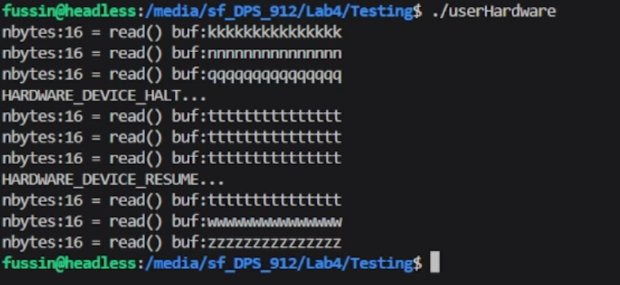

Logs
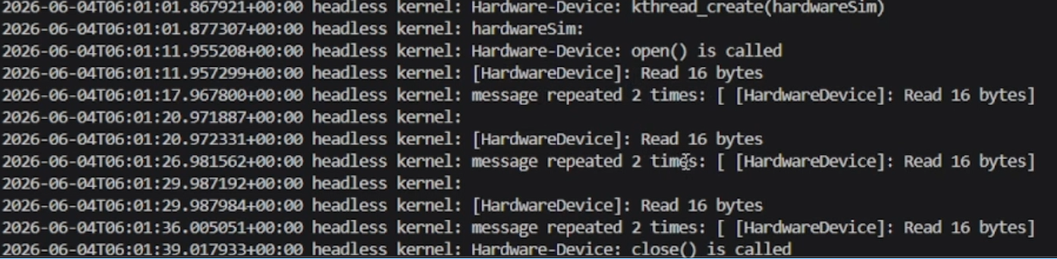

- They do match in what they do, as the reads are happening, just that the program output shows the updates to the buffer whereas the kernel logs doesn’t. The output logs show more of the process and explicitly what occurs (HARDWARE_DEVICE_RESUME … ) whereas the kernel doesn't; however, the kernel shows more internal details of what is occurring.
- The reason they don’t match is the kernel compresses identical messages into 1 and just shows how many times it was repeated. The reason the message content isn’t the same is because the print message is different on the kernel side from the user side

